PRACTICAL SESSION-8

Task 1 : Develop a program using malloc(), calloc(), realloc(), and free(). Monitor memory allocation behavior and identify memory leaks using Valgrind.

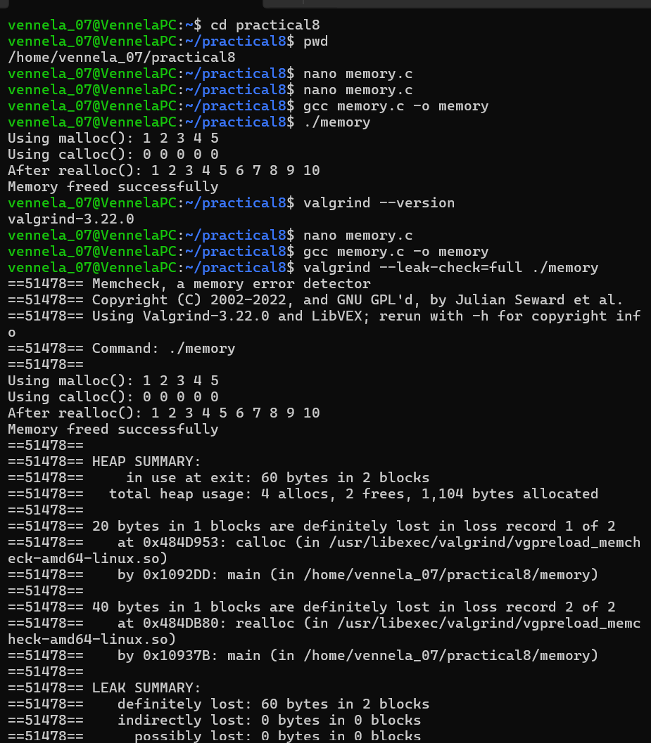

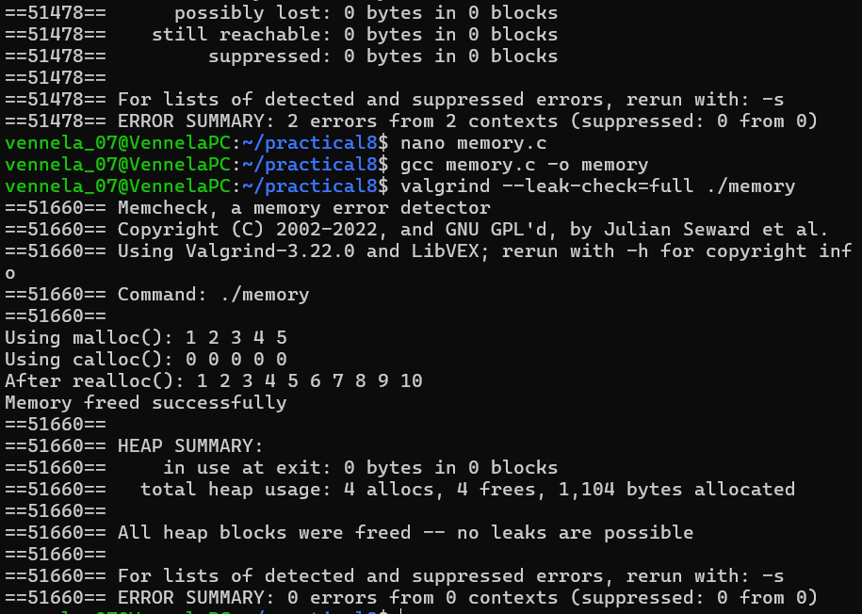

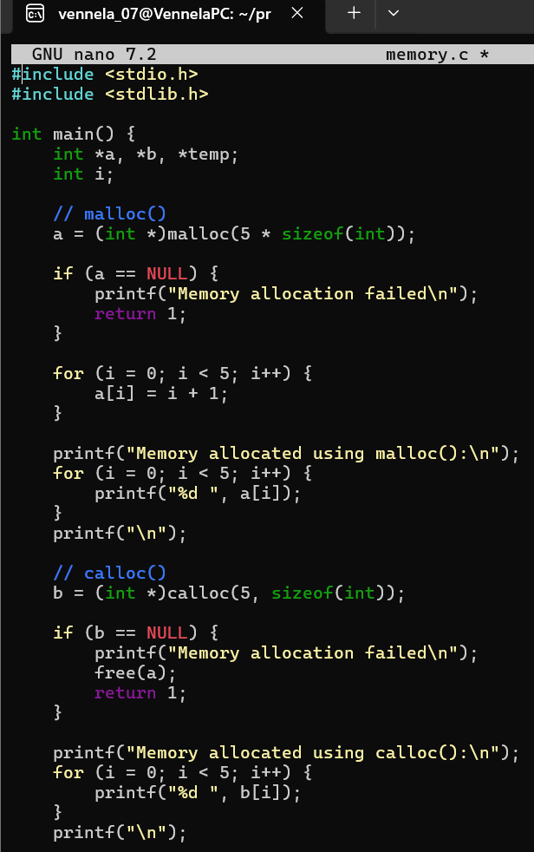

Task 2 : Develop a program that demonstrates Copy-on-Write behavior after a fork(). Analyze memory usage before and after modifying data in the child process.

